E6225
All the assignment must submitted by
Due: Saturday, week 7, 25 Sep 2021
Format: The solution must be submitted in word document by e-mail
Continious Assignment 1
  - A process transfer function is described as
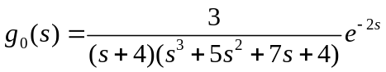
Write a Simulink/Mathlab software program to simulate the process (note that this is the process you are not to make any change in the following works) and to identify the parameters of the transfer function
- Frist order plus time delay model using classic technics: two points method, log method and area method
- Frist order plus time delay model using least squares mentod under open loop step test in time domain
- Frist order plus time delay under open loop step test using least squares mentod in frequency domain
- Using relay feedback to generate sustained oscillation and using the available informatuion to calculate the parameters of frist order plus time delay model.
- For rach method, plot Nyquist chart for both the original transfer function and the identified transfer function to compare the identification results
Note: You need to show the program and step by step results.

